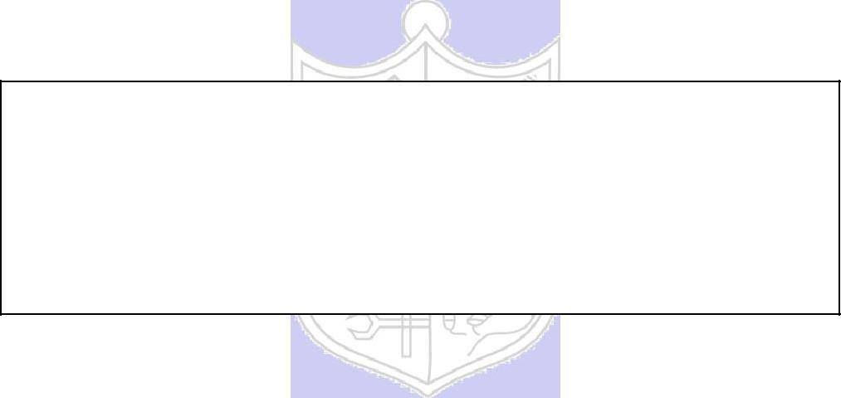

**Experiment No.: 08**

**Title:** To demonstrate database application

<https://www.youtube.com/watch?v=w7min7VR98I&feature=youtu.be>

(Autonomous College Affiliated to University of Mumbai)

# Batch: B1 Roll No.: 1914078 Experiment No.: 08

**Aim: To demonstrate database application.**

**Resources needed:**

XAMPP Control Panel, MySQL, Apache Server, phpMyAdmin, Any text editor (here, Notepad)

# Results: write answers to following questions after watching the video

# Which front end and backend software’s are used in demo?

# Ans. Softwares used for in demo are as follows:

# Front End – HTML

# Back End – PHP, MySQL

# Which server is used for database connection

# Ans. The server used for database connection is Apache Server.

# Where should we place all our project files

# Ans. Our project files have to be stored in the following location: [ C:\xampp\htdocs ].

# This location shows the folder named ‘htdocs’ in ‘xampp’ folder, in whichever drive it is saved on the device ( i.e here C drive).

# What is use of mysqli-connect.php file

# Ans. The mysqli-connect.php file is the first file to be executed that establishes a connection with the server.

# Outcomes:

Realize the features of Database Management Systems

Illustrate the concept of security, Query processing, indexing and Normalisation for the Relational Database.

**Questions:**

**Q1 What is backend, middleware and frontend, explain with example.**

**Ans.**

**Front end** – This relates to the Software’s presentation layer, essentially the user interface (UI) and User Experience (UX). This is basically what elements of the software are visible by the end user and what their interactions with the system will be. Typically we want this to look good and user friendly so front end developers often have web design skills and can find their way around design tools like Photoshop. Typically code used here will include HTML, Javascript and CSS along with framework tools like Jquery and Bootstrap. This enables the developer to build the screen layouts, menus, folders, buttons and all the other bits that the user will see on their screen when using the software.

**Back end** – This relates to the Software’s data tier or persistence layer. Typically this is the database(s) that the software is built on which is not directly presented to the user. So once a user requests data, clicks on an option or issues a command of some sort through the UI this is where the data is stored, found by the software, retrieved and then displayed back to the user. It basically serves up the requested information. Typically code used here will include PHP, C, C++, C#, Python and .Net along with a tool that communicates with the database such as MySQL. This enables the developers to build applications that can efficiently and quickly search, locate and present data.

**Middleware** – is referred to as middle tier. Essentially Middleware links the front and back end of the system together acting as a bridge between the front and back end. It is often referred to as the glue between the data and the UI. The Middleware is therefore often where the business logic resides. Typically code used here will include Java and C# and frameworks like SOAP and JSON are used to communicate throughout the breadth of the software.

**Conclusion:**

We understood the way to connect databases and the basics of database management systems.

**Grade: AA / AB / BB / BC / CC / CD /DD Signature of faculty in-charge with date**

**Reference books:**

(Autonomou of Mumbai)

s College Affiliated to University

1. Elmasri and Navathe, “Fundamentals of Database Systems”, 6th Edition, Pearson Education
2. Korth, Slberchatz,Sudarshan, :”Database System Concepts”, 6th Edition, McGraw – Hill.

# WebSite:

1. <https://www.youtube.com/watch?v=w7min7VR98I&feature=youtu.be>
2. <http://www.tutorialspoint.com/postgresql/>

(Autonomous College Affiliated to University of Mumbai)